FINAL ASSESSMENT REPORTING FORM
(To be Completed by Faculty)
Program or Course: PSY 101
Date: 05/25/2021
Number of Student Participants: 155
Number of Faculty/Staff Participants: 3 fulltime
Name of person completing report: Liz Baroi
Assessment Reporting Form: This report is to show that assessment is occurring and that the results are being used to make changes to improve student learning. The assessment being reported could be an assessment of a Program Learning Outcome (PLO) or a Measurable Student Level Outcome (MSLO). Each program should be assessing and gathering data for at least two PLOs OR two MSLOs that contain CSLOs each year.
1. What PLOs and/or MSLOs and CSLOs did you assess this year?

Fall 2020/Spring 2021-

The four CSLOs present diverse opportunities which naturally connect to specific content knowledge and skills taught in Introduction to Psychology (PSY 101). The intent of SBS psychology instructors is to ensure that students realize the inherent and instinctive connection between the two. Faculty validate the transfer of course content knowledge to practical application in the world. Fall 2020 data provided a baseline for subsequent semesterly comparisons. Spring 2021 results serve as our first comparison data.

CSLO 1: Cultural and Civic Engagement
Participate in diverse environments while demonstrating global citizenship and social consciousness.

CSLO 2: Integrative Knowledge
Identify, comprehend, apply, and synthesize facts, concepts, theories, and practices across broad and specialized knowledge areas.

CSLO 3: Personal and Professional Skills
Demonstrate skills which enhance personal and professional development.

CSLO 4: Reasoning Skills
Inquire and analyze to solve problems, draw logical conclusions, or create innovative ideas.

2. Describe the assessment method used and criteria for successful achievement of student learning outcomes. (e.g., rubrics, licensing exam, internship, portfolio, exam, research paper, performance exam, EAC, etc.)

Students were asked to complete a six-question survey assessing level of attainment in each of the four Common Student Learning Outcomes (CSLOs) using a seven-point Likert scale as follows:

- Strongly disagree
- Disagree
- Somewhat disagree
- Neutral
- Somewhat agree
- Agree
- Strongly agree.

Students also reported the name of their PSY 101 instructor.

A 70% combined response rate of Agree OR Strongly agree is considered passing. Responses of Somewhat agree were not included because they are considered insubstantial as robust evidence.

INTRODUCTION TO MAY 2021 RESULTS AND THEIR INTERPRETATION
American Psychological Association psychology researchers pride themselves in honesty and truth, even when the results of a study are dismal. Dismal is a construct to be faced, dealt with, and successfully resolved. Specifically, why do some students disagree?

While the Spring 2021 results reflected improvement over Fall 2020 results, it is important to consider any students who disagreed at some level or those who were neutral. There are several potential explanations ranging from the imprudent student to negligence on the part of the instructor. Neither student nor instructor are infallible and must be accountable for their actions. This is a topic which will be discussed with all fulltime and adjunct PSY 101 instructors during a meeting in September 2021. As instructors, we continuously need to clarify the connection between psychological content and CSLO using examples to help more students see engage content knowledge in day-to-day CSLO applications.

3. How many students were proficient in the PLOs OR MSLOs and CSLOs? What was determined as proficient? (i.e., 70% = proficient)

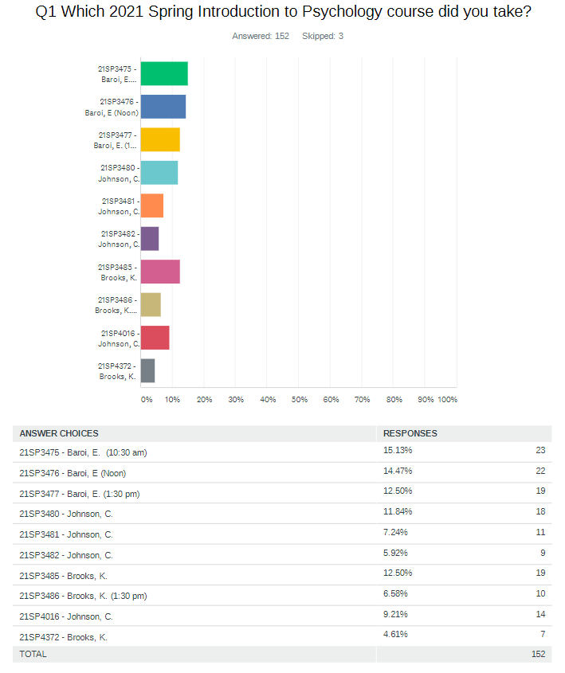

Q1 SUMMARY
Beginning-of-the-semester enrollment numbers in a PSY 101 class typically range from 24-30. Indeed, some students drop the course at one point; however, headcount less than 15-20 by May is rare. PSY 101 needs to work harder to garner greater compliance in survey completion. As a team, we presented the survey as an assignment (Johnson, Baroi) or extra credit (Brooks).
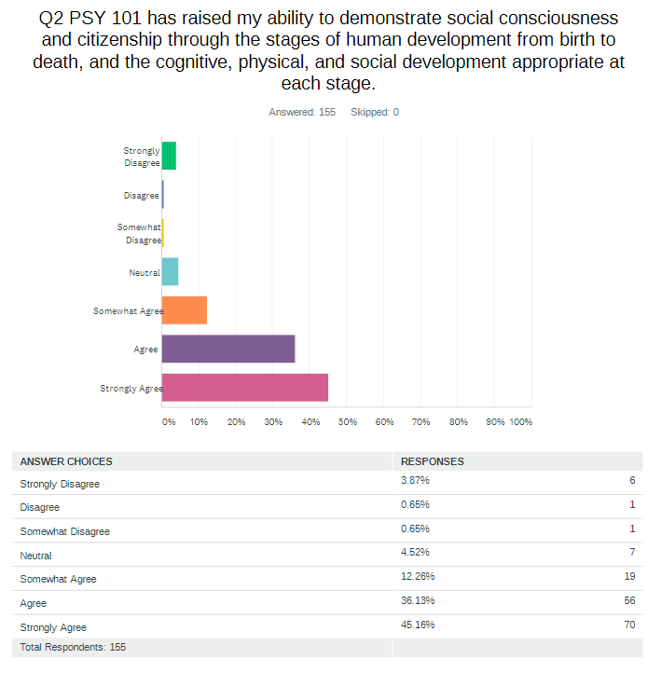 Q2 SUMMARY: (Proficiency = 70% or higher. Obtained = 81% Woohoo!)
- Approximately 81% of the 156 students surveyed in Spring 2021 reported that PSY 101 had raised their ability to demonstrate social consciousness and citizenship through the stages of human development from birth to death, and the cognitive, physical, and social development appropriate at each stage.
- This presents as a 6% increase from the 75% of the 137 students surveyed in Fall 2020. The results constitute a pass for CSLO 1.

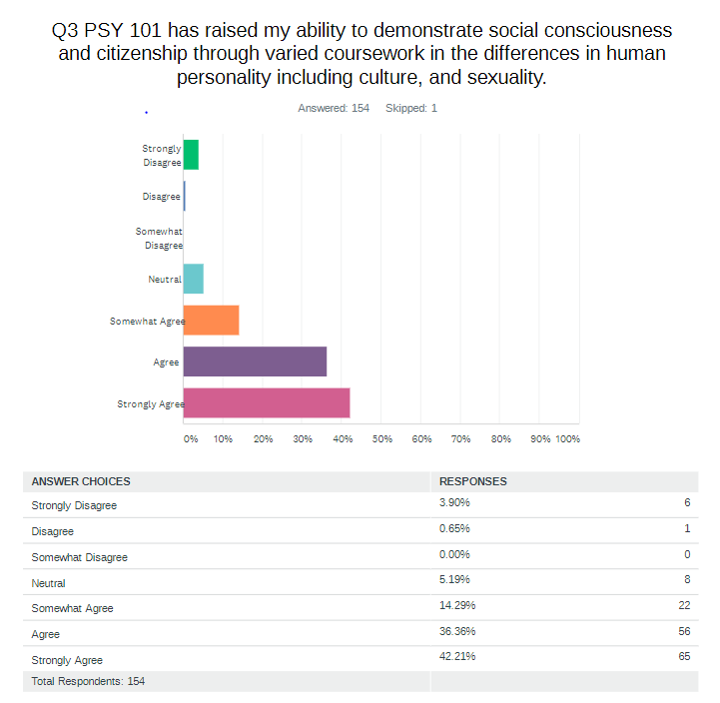
Q3 SUMMARY: (Proficiency = 70% or higher. Obtained = 79%)

Approximately 79% of the 154 respondents reported that PSY 101 had raised their ability to demonstrate social consciousness and citizenship through varied coursework in the differences in human personality including culture, and sexuality.

This represents a 4% increase from 75% of the 137 students surveyed last Fall 2020. The results constitute a pass for CSLO 1.
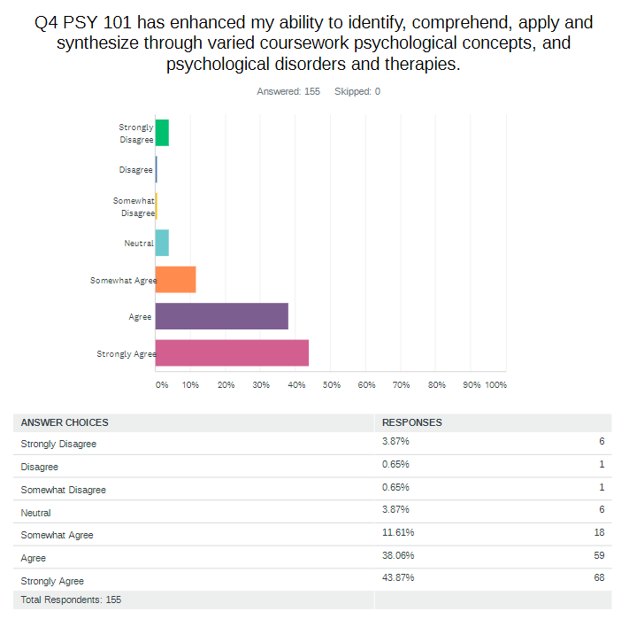
SUMMARY Q4: (Proficiency = 70% or higher. Obtained = 82% Woohoo!)

Approximately 82% of the 155 respondents noted that PSY 101 had increased their ability to identify, comprehend, apply, and synthesize through varied coursework psychological concepts, and psychological disorders and therapies.

This is a 12% increase from Fall 2020 results where 69%% of the 137 respondents agreed, constituting a conditional pass. Spring 2021 presents 82% and a pass for CSLO 2.
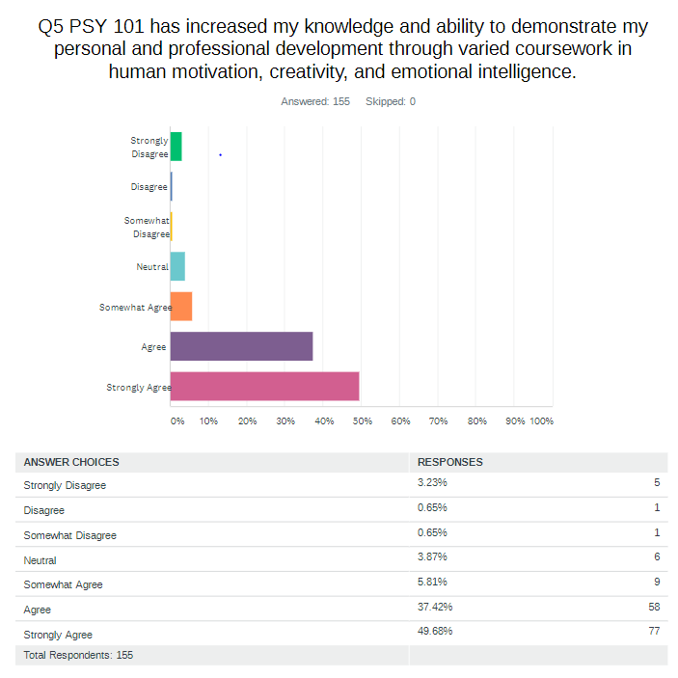
SUMMARY Q5: (Proficiency = 70% or higher. Obtained = 87% Woohoo!)

Approximately 87% of the 155 respondents noted that PSY 101 had increased their knowledge and ability to demonstrate personal and professional development through varied coursework in human motivation, creativity, and emotional intelligence. This represents an 8% increase over the 79% reported last Fall 2020.

The results constitute a strong pass for CSLO 3. The psychological lectures are likely to have been more closely and clearly connected to this CSLO. This will be reviewed by the PSY 101 team.
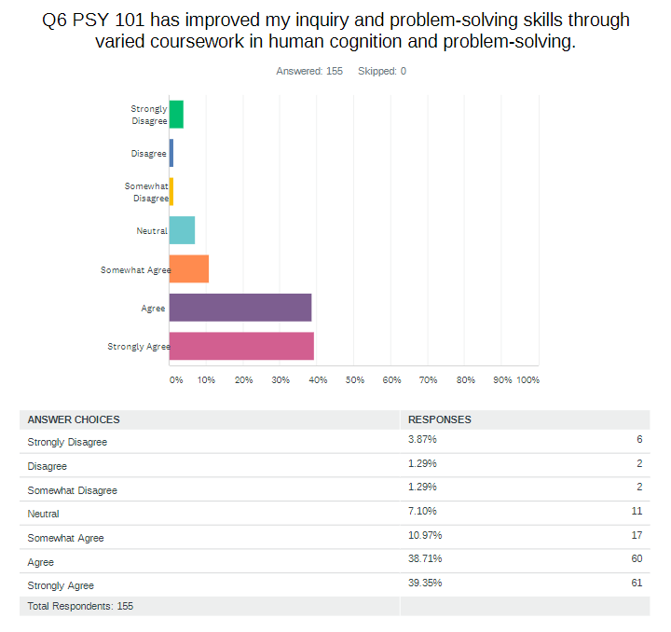
Q6 SUMMARY: (Proficiency = 70% or higher. Obtained = 78%)

Approximately 78% of the 155 respondents noted that PSY 101 had improved inquiry and problem-solving skills through varied coursework in human cognition and problem-solving.

This is a 6% increase over the 72% of the 137 respondents from Fall 2020.
The results constitute a pass for CSLO 4.

4. What changes/improvements were made or will be made in response to the outcomes of the assessment process?

Spring PSY 101 faculty members (3) met for discussion of Fall 2020 survey results in March 2021 and determined to present the survey as a graded assignment or extra credit. Increasing the number of respondents remains a concern. Faculty identified/included specific CSLOs throughout chapter topics in the Spring 2021 syllabus, Discussion Boards, and other assignments to build a clearer and more direct connection between lecture topic and CSLO. Engaging these practices appear to have had an impact on student responses as evidenced by the overall increases above 75% in all CSLO questions.

All PSY 101 faculty teaching Fall 2021 will meet in September to compare Fall 2020 with Spring 2021 results. Discussion will include how to
- increase student response rate,
- exemplify integration of each Common Course Learning Outcome in specific course content that supports each of the four CSLO and which psychology lectures best support specific CSLOs. Faculty discussion to include creating new assignments or modification of existing ones to create a stronger connection between lecture and CSLO.

Accomplishing item 2 may decrease the number of students who failed to agree or who were neutral by providing additional clarity, depth, and breadth between lecture topic and CSLO.

It was expected to reach 75% in each CSLO survey question at the end of Spring 2021. Survey results indicate success across all CSLOs.

Feel free to attach your PLOs OR MSLOs and CSLOs and indicate which were assessed

