ASSESSMENT REPORTING FORM
(To be Completed by Faculty)
Program or Course: PSY 101: Introduction to Psychology
Date: 10/27/20
Number of Student Participants: Approximately 137
Number of Faculty/Staff Participants:
Fulltime PSY faculty: 3
Adjunct PSY faculty: 6
Name of person completing report: Liz Baroi
Assessment Reporting Form: This report is to show that students have and that the results are being used to make changes to improve student learning. The assessment being reported could be an assessment of a Program Learning Outcome (PLO) or a Measurable Student Level Outcome (MSLO). Each program should be assessing and gathering data for at least two PLOs OR two MSLOs that contain CSLOs each year.
- What PLOs and/or MSLOs and CSLOs did you assess this year?

Fall 2020/Spring 2021-

The four CSLOs present diverse opportunities which naturally connect to specific content knowledge and skills taught in Introduction to Psychology (PSY 101). The intent of SBS psychology instructors is to ensure that students realize the inherent and instinctive connection between the two. Faculty validate the transfer of course content knowledge to practical application in the world.

CSLO 1: Cultural and Civic Engagement
Participate in diverse environments while demonstrating global citizenship and social consciousness.

CSLO 2: Integrative Knowledge
Identify, comprehend, apply and synthesize facts, concepts, theories and practices across broad and specialized knowledge areas.

CSLO 3: Personal and Professional Skills
Demonstrate skills which enhance personal and professional development.

CSLO 4: Reasoning Skills
Inquire and analyze to solve problems, draw logical conclusions, or create innovative ideas.

- Describe the assessment method used and criteria for successful achievement of student learning outcomes. (e.g., rubrics, licensing exam, internship, portfolio, exam, research paper, performance exam, EAC, etc.)

- Describe how data were analyzed and evaluated.

Students were asked to complete a six-question survey assessing level of attainment in each of the four Common Student Learning Outcomes (CSLOs) using a seven-point Likert scale as follows:

- Strongly disagree
- Disagree
- Somewhat disagree
- Neutral
- Somewhat agree
- Agree
- Strongly agree.

Students also reported the name of their PSY 101 instructor.

A 70% combined response rate of Agree OR Strongly agree is considered passing. Responses of Somewhat agree were not included because they are considered insubstantial as robust evidence.

3. How many students were proficient in the PLOs OR MSLOs and CSLOs and how many were not? What was determined as proficient? (i.e. 70% = proficient)

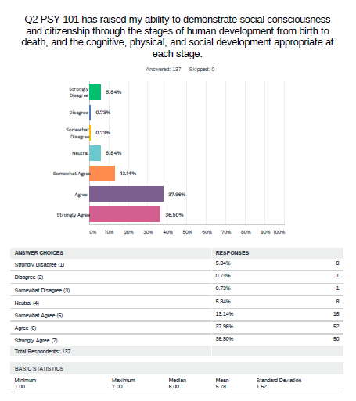

SUMMARY:
Approximately 75% of the 137 students surveyed reported that PSY 101 had raised their ability to demonstrate social consciousness
and citizenship through the stages of human development from birth to
death, and the cognitive, physical, and social development appropriate at
each stage. The results constitute a pass for CCSLO 1.

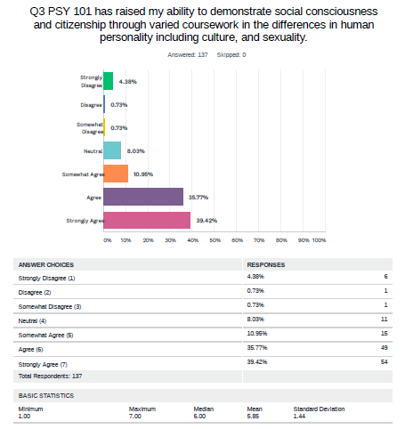
SUMMARY:
Approximately 75% of the 137 students surveyed reported that PSY 101 had raised their ability to demonstrate social consciousness and citizenship through varied coursework in the differences in human personality including culture, and sexuality. The results constitute a pass for CCSLO 1.

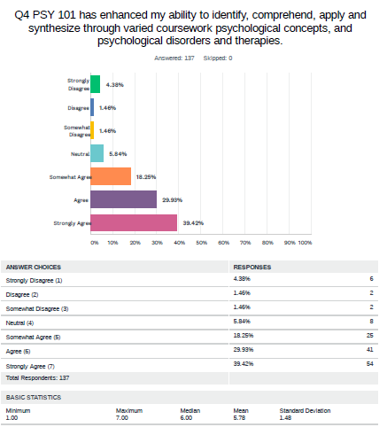
SUMMARY:
Almost 70% of the 137 respondents noted that PSY 101 had increased their ability to identify, comprehend, apply and synthesize through varied coursework psychological concepts, and psychological disorders and therapies. The results constitute a conditional pass for CCSLO 2 as the total was 69.40%.
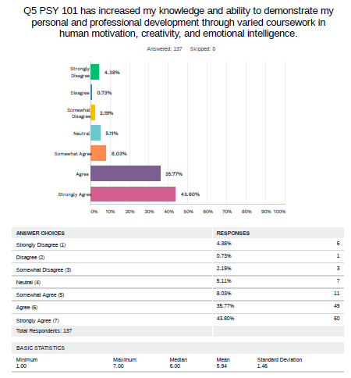
SUMMARY:
Approximately 79% of the 137 respondents noted that PSY 101 had increased their knowledge and ability to demonstrate personal and professional development through varied coursework in human motivation, creativity, and emotional intelligence.
The results constitute a pass for CCSLO 3.
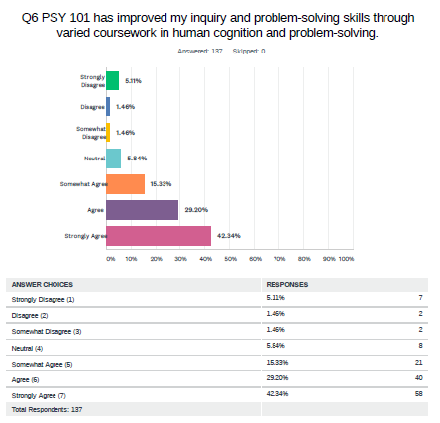
SUMMARY:
Approximately 72% of the 137 respondents noted that PSY 101 had improved inquiry and problem-solving skills through varied coursework in human cognition and problem-solving.
The results constitute as a pass for CCSLO 4.
4. What changes/improvements were made or will be made in response to the outcomes of the assessment process?

All faculty teaching PSY 101, Introduction to Psychology will be trained in the following by February 19, 2021:
- How to get every student to complete the survey (post as a grade). Our n-size was low due to an unavoidable challenge.
- How to exemplify integration of each Common Course Learning Outcome in specific course content that supports each of the four CSLO.

We expect to reach 75% in each CSLO at the end of Spring 2021.

Feel free to attach your PLOs OR MSLOs and CSLOs and indicate which were assessed

