BENCHMARK ASSESSMENT REPORTING FORM
(To be Completed by Faculty)
Program or Course: HRM100
Date: 10/22/20
Number of Student Participants:
Number of Faculty/Staff Participants:
Name of person completing report: Amanda Potts
Assessment Reporting Form: This report is to show that assessment is occurring and that the results are being used to make changes to improve student learning. The assessment being reported could be an assessment of a Program Learning Outcome (PLO) or a Measurable Student Level Outcome (MSLO). Each program should be assessing and gathering data for at least two PLOs OR two MSLOs that contain CSLOs each year.
1. What PLOs and/or MSLOs and CSLOs did you assess this year?
1. (Knowledge level) Explain the historical development of the hotel, restaurant, recreation, tourism, and travel industries.
2. (Comprehension level) Describe the importance of guest service and the hospitality spirit.
3. (Comprehension level) Compare and contrast lodging, foodservice, travel, tourism, attractions, recreation, and gaming establishments.
4. (Knowledge level) Outline the major organizational areas within hotels and restaurants.
5. (Comprehension level) Describe management concepts within the hospitality industry.
6. (Comprehension level) Describe marketing applications for individual and group travel within the hospitality industry.
7. (Comprehension level) Describe leadership and supervisory concepts within the hospitality industry.

2. Describe the assessment method used and criteria for successful achievement of student learning outcomes. (e.g., rubrics, licensing exam, internship, portfolio, exam, research paper, performance exam, EAC, etc.)

AHLEI American Hotel & Lodging Education Institute National Industry Certification.
Issued as a final exam. The certification is awarded to students with a score of 75% or higher.

3. How many students were proficient in the PLOs OR MSLOs and CSLOs and how many were not? What was determined as proficient? (i.e. 70% = proficient)

 | Spring 2019 | Fall 2019 | Summer 2020 | Fall 2020
Students in class | 12 | 26 | 6 | 22
Students Passed Certification | 4 | 4 | 6 | 10
Pass % | 33% | 15% | 100% | 45%

4. What changes/improvements were made or will be made in response to the outcomes of the assessment process?

We have seen a significant increase in passing certifications in the last year as well as an increase in the overall average of final percentage for the whole class. This is a result of three factors.

The first is a change in the structure of homework. The course has shifted away from chapter questions as a source of knowledge checks. Homework has instead been replaced with “Class Creates” a free form project-based case study designed to challenge students to create solutions for industry-based problems. Students choose how they will build their project based on their learning style. The options ranging form posters, PowerPoints, articles, video, recordings, etc. The point is the student chooses the format and create something that could be presented in a professional setting. The overall objective was to apply Blooms Taxonomy having Students are create what they are learning instead of using basic knowledge to answer questions. Class Creates were implemented in all the HRM Fall 2020 courses and are currently being updated in the Spring 2021 courses. Below is an example of one of the Class Creates.

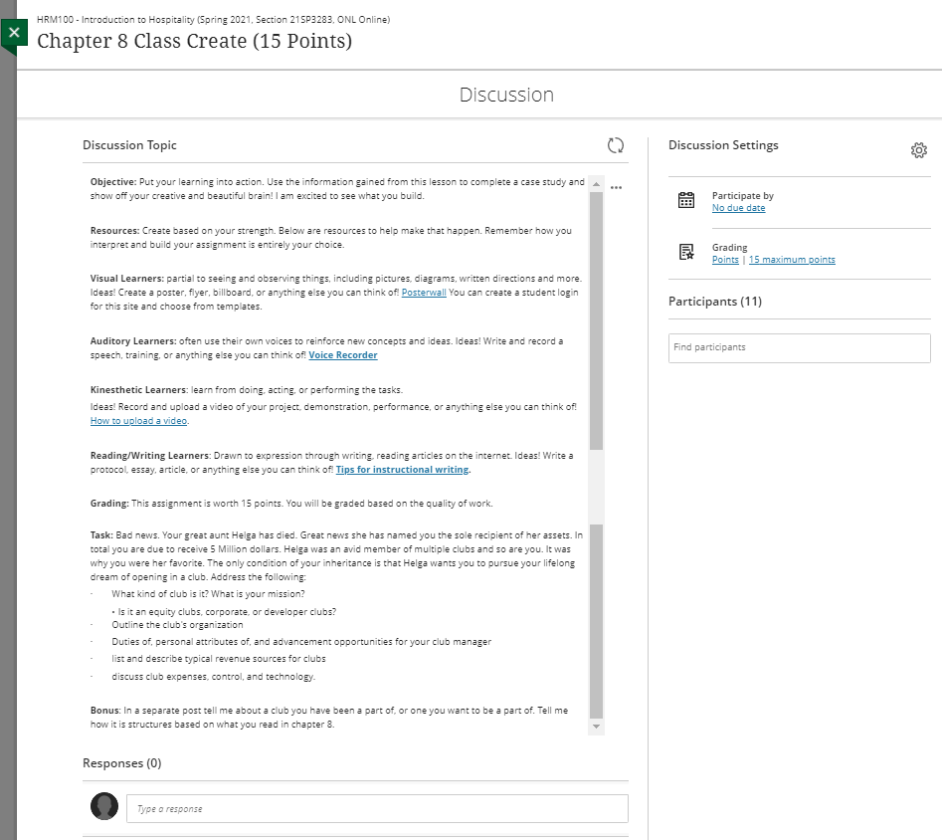

The second improvement is the implementation of an end of year study guide session. I have been doing a 1-2 hour online review for students in each class I teach to take notes and prep for the final exam the week before the semester ends.

Lastly, I have implemented a new simulation software into the courses that allow students to apply what they learn in class to a video game style assignment. Students open and run a virtual restaurant or hotel. They can directly apply what they have learned to each simulation scenario and fast forward through time to see how their actions affect profit margins and occupancy. These simulations also implement a strong industry math component, which many students have struggled with in the past. 3-4 different simulations are spread throughout each HRM Course and CUL170 as well as CUL185. The simulation has no added cost to the college or students.

Planning for the future: I am working with the Math Department to implement a math course that can be taken specifically by HRM and Culinary students. This will allow the Math department to teach directly to the math concepts needed for our industry. The hope is to bridge our knowledge between core and traditional academic courses and ensure academic triumph for our students.

If interested I have created a mock Hotel and Culinary Course that contains all the Knowledge Matters Simulations. One would only need to create a login in and use the course codes below for access.
Website: https://vb.knowledgematters.com/
Restaurant Course Key: EP9ZW2
Hotels Course Key: RP9MN3

Feel free to attach your PLOs OR MSLOs and CSLOs and indicate which were assessed

