**BIO181 course assessment data analysis of Fall 2020**

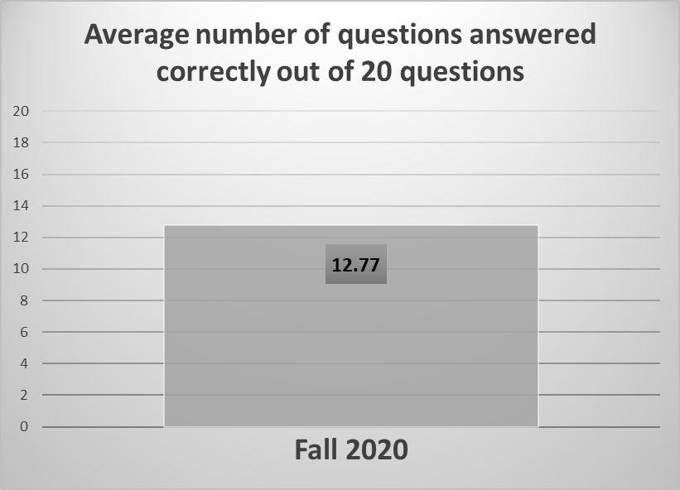

Figure1. Average number of questions answered correctly from126 students out of 20 questions from the Fall 2020 assessment test.

Total 126 students took the test on Fall 2020 online class. Average number of questions answered correctly were 12.77. About 60% of questions were correctly answered. This result is very similar with the data from the spring 2020 and higher than in person classes. It indicates that switch to online on spring 2020 didn’t cause adverse effect.

Take-home message from the data:

1. How to increase the number of questions answered correctly from 10 (50%) to more than 14 (70%) out of 20 total questions in the future.

Figure 2. Number of students (%) answered correctly in each question.

|  |  |  |  |  |
| --- | --- | --- | --- | --- |
| Question # | Learning objective | MSLO | CSLO | Number of student answer correctly (%) |
| 1 | *Seven themes of life* | MSLO1 | CSLO2 &4 | 59 |
| 2 | *Scientific hypothesis and method* | MSLO2 &3 | CSLO2 &4 | 61 |
| 3 | *pH* | MSLO4 | CSLO2 &4 | 61 |
| 4 | *Carbon character* | MSLO4 | CSLO2 | 68 |
| 5 | *Property of the H2O* | MSLO5 | CSLO2 | 43 |
| 6 | *Macromolecule* | MSLO6 | CSLO2 &4 | 58 |
| 7 | *Organelles* | MSLO7 | CSLO2 | 72 |
| 8 | *Organelles* | MSLO7 | CSLO2 | 79 |
| 9 | *Membrane structure* | MSLO8 | CSLO2 | 36 |
| 10 | *Cellular respiration* | MSLO9 | CSLO2 | 32 |
| 11 | *Cellular respiration* | MSLO9 | CSLO2 | 70 |
| 12 | *Cell communication* | MSLO10 | CSLO2 | 62 |
| 13 | *Mitosis and Meiosis cell reproduction* | MSLO11 | CSLO2 | 44 |
| 14 | *Mitosis and Meiosis cell reproduction* | MSLO11 | CSLO2 | 61 |
| 18 | *Mitosis and Meiosis cell reproduction* | MSLO11 | CSLO2 | 68 |
| 15 | *Inheritance, Punnet square* | MSLO12 | CSLO2 &4 | 66 |
| 16 | *Inheritance and X-linked disorder* | MSLO13 | CSLO2 &4 | 51 |
| 17 | *Karyotype?* | MSLO13 | CSLO2 | 55 |
| 19 | Translation and trasncription (gene expression) | MSLO15 | CSLO2 &4 | 30 |
| 20 | *DNA replication* | MSLO14 | CSLO2 | 46 |

**Results**

**Questions** less than 50 % of students answered correctly

Question 5 (MSLO5): Property of H2O

Question was not hard. Students didn’t understand the property of H2O

Question 9 (MSLO8): Membrane structure

Question was not hard. Students didn’t understand the membrane structure

Question 10 (MSLO9): Cellular respiration

Two questions tested for this Cellular reparation. Level of the question 10 is hard so only 32% answer the question. However, question11 for same MSLO was moderate and 70% of students answer correctly. It indicates that students understood cellular reparation learning objective.

Question 13 (MSLO11): Mitosis and Meiosis cell reproduction

Three questions tested for the Mitosis and Meiosis cell reproduction learning objective. Level of the question 13 is hard so only 44% answered question. However, other two questions14 and 15 for the same MSLO were moderate and 61% and 68% of students answered correctly. It indicates that students understood Mitosis and Meiosis cell reproduction learning objective.

Question 19 (MSLO15): Translation and trasncription (gene expression)

Question was not hard. Students didn’t understand gene expression

Question 20 (MSLO14): *DNA replication*

Question was not hard. Students didn’t understand DNA replication

**Discussion**

We should improve the teaching method for, Question 5 (MSLO5): Property of H2O, Question 9 (MSLO8): Membrane structure, Question 19 (MSLO15): Translation and trasncription (gene expression) and Question 20 (MSLO14): *DNA replication*