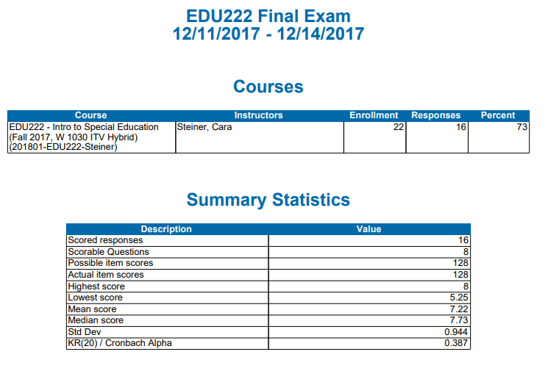

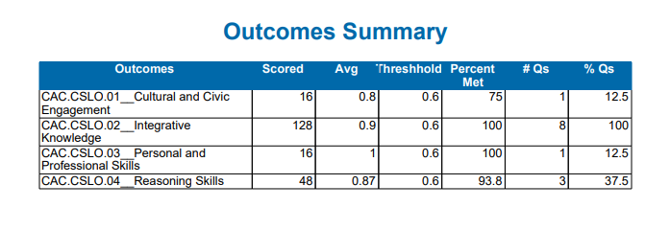

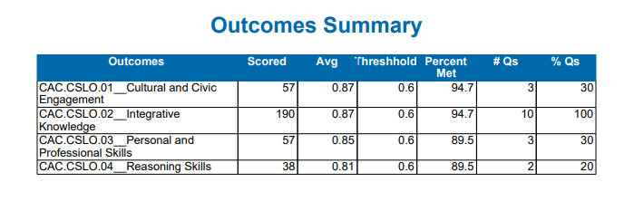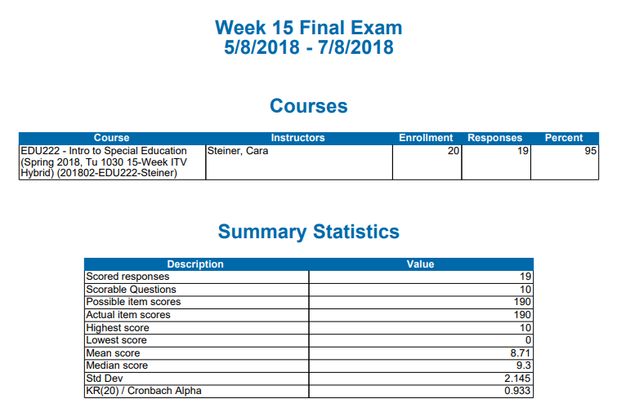

**EDU222 Final Exam**

The dates from 5/8/18 to 7/8/15 are accurate. The final exam dates included several students completing an Incomplete Grade Contract from Spring 2018.