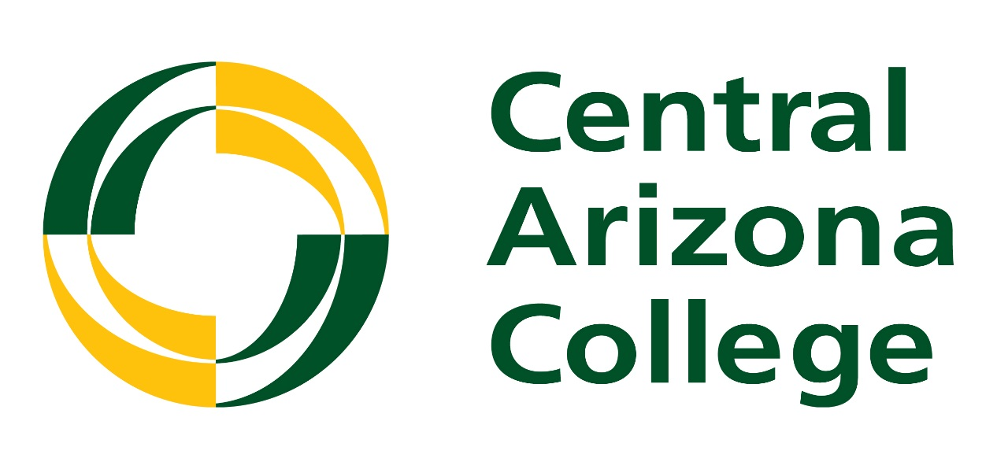

**Academic Program Review Handbook**

**2019**

**Table of Contents**

Defining Academic Program Review 3

Overview of the Academic Program Review Process 4

Roles in the Academic Program Review Process 5

Writing the Self-Study 8

Completing Curriculum Comparison Charts 11

Peer Review Process/Peer Review Panel Reports 13

Developing the Action Plan 15

**Defining Academic Program Review (APR)**

In 2012, Central Arizona College, revised its academic program review process, moving from a division-based review to a process focused on assessing and evaluating individual degree and certificate programs. Each degree and certificate program must engage in a self-study every five years. A team of internal peer reviewers evaluate the program using the information provided in the self-study. ALL degree programs and certificates must go through the internal academic program review process even if the program also engages in self-study evaluations for an external accreditation. The academic program review process is governed by Central Arizona College Policy and Procedure 575.

On December 9, 2014, the CAC Academic Program Review Committee approved the following purpose statement which guides the APR process at CAC:

**The Academic Program Review Process will…**

* Evaluate the effectiveness of the academic program in achieving its stated educational goals.
* Evaluate the viability and sustainability of the academic program.
* Evaluate the quality and strengths of the overall program curriculum.
* Ensure the program is aligned with community needs, the college’s mission, and the college’s strategic goals.
* Evaluate the adequacy of resources available to the program, and provide a vehicle for documentation of resource deficiencies.
* Help identify strategic plans and priorities for future enhancement of the academic program.
* Intersect with the curriculum updating processes, student learning outcome assessment processes, and the operational planning process by both providing information for and using information produced from those processes.

In addition, Academic Program Review is an important process according to our regional accreditor, The Higher Learning Commission. It helps us achieve the following accreditation criterion and core components:

**Criterion Four. Teaching and Learning: Evaluation and Improvement**

The institution demonstrates responsibility for the quality of its educational programs, learning environments, and support services, and it evaluates their effectiveness for student learning through processes designed to promote continuous improvement.

**Core Components**4.A. The institution demonstrates responsibility for the quality of its educational programs.

1. The institution maintains a practice of regular program reviews.

**Overview of the Academic Program Review Process**

Academic program review operates on a five-year cycle, meaning each degree and certificate must complete a self-study once every five years. The process of writing and assessing the self-study occurs during one calendar year, beginning in January 2018 and ending in December 2018. The following chart details a basic overview of the process:

Academic Program Review at CAC is a central process in that it provides an opportunity for multiple other processes to intersect and influence one another. Academic Program Review intersects with the following process:

* **External Accreditation –** Programs which have external accreditation reviews should use the internal and external self-studies to inform the other. Generally the internal self-study is briefer, and should be able to pull substantially from the external review, as well as help the program continue to prepare for any upcoming external reviews.
* **Operational Planning –** Programs will develop Action Plans upon receipt of the Review Panel Report. The goals and actions for program improvement can and often should be addressed as operational planning goals.
* **Student Learning Outcome Assessment-** The degree to which students are achieving the learning outcomes in the program and its courses is a key measure of program effectiveness. Thus the Academic Program Review process serves as a key vehicle for reporting and evaluating your assessment results.
* **Curriculum Planning and Revision –** Curriculum is closely related to the effectiveness and viability of the program. As part of the Academic Program Review Process a thorough curriculum evaluation is completed, and thus the APR process should inform a program’s curriculum updating and revision process.

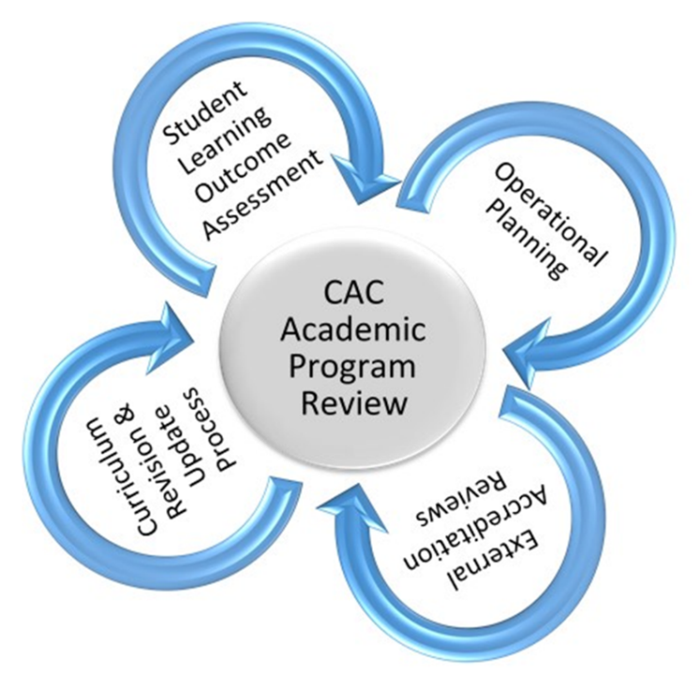

It can be helpful to think of the APR process serving as the central point in this intersection; it is influenced by as well an influencer of the other processes surrounding it.

**Roles in the Academic Program Review Process**

Many people are involved in the Academic Program Review Process. One of the most important roles is that of CAC’s **Assessment Committee**. This committee is the “owner” of the process.

**The Committee Charge:**

Create a systematic process for instructional program review that ensures quality teaching and learning, relevancy of curriculum and instruction, and fulfillment of the program’s mission. The committee will continually evaluate and make recommendations for improvement to the program review process.

**The APR Committee’s Responsibilities:**

* Monitor, recommend and approve any changes to the Academic Program Review Process
* Monitor, recommend and approve any changes to academic program review templates and tools used in the process.
* Approve Program Cycle
* In conjunction with coordinator write and submit to CAO overall summary report of Academic Program Review each year.
* Be an advocate for the value of academic program review at CAC

Another key role in the process is that of the **Academic Program Review Coordinator.** The coordinator works with others involved to ensure that the self-studies are completed and evaluated in a high quality and timely manner. The Academic Program Review Coordinator is selected by and reports to the VP of Academic Affairs.

**Job Description of the Coordinator:**

The coordinator is a faculty member with 3 credit hours of release time during fall and spring semesters and is paid a stipend for the academic year equal to 3.5 hours at adjunct pay who has expertise in the area of academic program review. The coordinator facilitates the process and works with self-study writers and peer reviewers to ensure that the self-studies and reviews are of high quality and completed on time. The coordinator works with programs to ensure that they use recommendations and information from the review process to make improvements to the academic programs at Central Arizona College.

**Academic Program Review Coordinator Responsibilities:**

* Assemble and provide training, guidance and assistance to those writing the self-studies.
* Receive completed self-studies from writers and deliver self-studies to the peer review teams for assessment.
* Ensure well-balanced and unbiased peer review teams are in place to review each self-study.
* Provide training, guidance and assistance to peer reviewers during the review process.
* Ensure peer review teams complete their work by due date, receive Review Panel Reports from the teams and forward them to appropriate Dean, CAO, and academic program leader.
* Continually keep the program cycle updated by adding and deleting programs as necessary.
* Attend APR Committee meetings.
* Ensure that Academic Program Review information and materials are updated and available to all who need them.
* Communicate with Deans and CAO as needed on all aspects of Academic Program Review.

People who manage CAC’s academic programs typically have the job title of Division Chair, Director, or Coordinator and they serve in the capacity of the **Self-Study Writers**. While they may certainly enlist assistance from others on their staff, the job of ensuring that the self-study is completed falls to them. These Self-Study Writers may also enlist the assistance of the Dean, the APR Coordinator, and the Office of Institutional Research in order to complete the self-study.

**Self-Study Writers Responsibilities:**

* Attend training for self-study writers offered by APR coordinator.
* Work with the APR coordinator, dean, and others to ensure the self-study is complete, accurate, and well-written.
* Submit the self-study by Sept. 9 to dean and APR coordinator.
* Meet for clarifications with peer reviewers if requested.
* Develop and follow up with Action Plan appropriately

**Peer Reviewers** are involved in the process after the self-studies are complete. Peer reviewers are typically faculty, preceptors, or staff who work directly with academic programs, or act as academic advisors. If you wish to serve as a peer reviewer please speak to your dean, program director, division chair or to the APR Coordinator. The APR Coordinator solicits deans, program directors, and division chairs each spring for the names of people who will serve as peer reviewers that coming fall. The division chairs will provide names to the APR Coordinator for peer reviewers

**Responsibilities of Peer Reviewers**

* Attend peer review training offered by APR coordinator.
* Offer an honest and constructive evaluation of the self-study, as it is submitted, according to the criteria established in the Review Panel Report.
* Meet with the self-study writer(s) for clarification of self-study if necessary.
* Return completed Peer Review Panel Comments and Recommendations to the APR coordinator by Oct. 14.

**Academic Deans** are also integral to the process. They can assist in the writing/compiling of the self-study if they wish. They assist in identifying peer reviewers. They are key to ensuring that programs follow up with the feedback received from peer reviewers as well as ensuring that the program is developing a strong Action Plan to address any key weaknesses discovered during the Academic Program Review process.

**Academic Program Review: Self-Study**

**Instructions:** The following pages will guide your submission of your academic program review self-study. Please type your responses directly into the document. The completed self-study instrument and all attachments must be submitted to the Academic Program Review Coordinator and your Academic Dean by September 1.

No more than one degree should be addressed in a self-study. Any certificates closely related to the degree and that share significant curriculum may also be included in the same self-study.

|  |
| --- |
| **Program Under Review** |
| Degree(s): |
| Certificate(s): |
| Contact Information for lead on Self-Study:  Name:  Campus:  Phone:  This should reflect the name of the division chair, program director or coordinator  Email: |

|  |
| --- |
| **Program Description, Vision and Outcomes** |
| 1. What is the description of the program as stated in the current CAC catalog: |
| 1. Does your program have a mission and/or a vision statement? If it does, please write them below and indicate where they appear.   Each degree or certificate has a description in the CAC catalog. Include and clearly label the description for each degree or certificate addressed in the self-study |
| 1. Describe how the program’s description, mission and/or vision aligns with the College’s Mission and Vision: |

|  |
| --- |
| **Program Enrollment and Graduation Trends** |
| 1. Summarize the program enrollment data for the past 5 years in the chart below:  |  |  |  |  |  |  | | --- | --- | --- | --- | --- | --- | | Degree/Certificate  Data for these charts will be supplied by the Office of Institutional Research in the form of a data package that contains the necessary information. | 2016-17 | 2015-16 | 2014-15 | 2013-14 | 2012-13 | |  |  |  |  |  |  | |  |  |  |  |  |  | |
| 1. Discuss and explain the factors influencing the enrollment trends: |
| 1. How has the program typically recruited students and marketed the program: |
| 1. Summarize the program graduation rate trends for the past 5 years in the chart below:  |  |  |  |  |  |  | | --- | --- | --- | --- | --- | --- | | Degree/Certificate | 2016-17 | 2015-16 | 2014-15 | 2013-14 | 2012-13 | |  |  |  |  |  |  | |  |  |  |  |  |  | |
| 1. How many program enrollees or graduates studied at an in-state baccalaureate level institution during the past 5 years? Put the data in the table below.  |  |  |  |  |  |  | | --- | --- | --- | --- | --- | --- | | Degree/Certificate | 2016-17 | 2015-16 | 2014-15 | 2013-14 | 2012-13 | |  |  |  |  |  |  | |  |  |  |  |  |  | |
| 1. Discuss and explain the graduation trends. What efforts has the program made to help students achieve completion? |
| 1. Provide a summary of this section. Indicate trends observed in the data, identify areas of strengths, and areas for improvement. |

|  |
| --- |
| **Program Curriculum:** *Submit a completed Curriculum Comparison Chart along with the self-study, comparing the CAC program curriculum to three similar programs, for each Degree and Certificate discussed in this self-study. Ideally compare to other Arizona programs, and out of state if necessary. Use the charts to answer the following questions.*  Please see instructions for the Curriculum Comparison Chart elsewhere in the handbook. In this section, discuss what you learned about the program curriculum by making the comparisons |
| 1. Certificate(s): After reviewing the Curriculum Comparison Chart of the other institutions for the certificate(s), is insight given into courses that could be added, combined or deleted? |
| 1. Degree (s): After reviewing the Curriculum Comparison Chart of the other institutions for the degree(s), is insight given into courses that could be added, combined or deleted? |
| 1. When the Curriculum Review for each degree and certificate comes due, are there any course descriptions, articulation, additions, revisions or deletions anticipated? |

|  |
| --- |
| **Program Outcomes and Assessment** |
| 1. What are the student learning outcomes for the degree or certificate as currently indicated in ACRES:   This can be found on the CAC Homepage under “Academics” then “Course Outlines and Other Needed Information.” This information can also be provided by the Office Curriculum and Student Learning Assessment |
| 1. Are the outcomes from your program determined or influenced by any external organization, agency, or accreditor? If so, please explain. Are there any available accreditations which the program does not have, but maybenefit from seeking? |
| 1. Describe the department/program strategies for determining how learning outcomes are assessed using direct and indirect methods and for collecting, analyzing and discussing findings. |
| 1. Is a common assessment being conducted to assess the Measurable Student Learning Outcomes (MSLOs) for a common course? Is there data which indicates the degree to which students in the program are achieving the program’s MSLOs? |
| 1. Is there data which indicates the degree to which students in the program are achieving the program’s Common Student Learning Outcomes (CSLOs)? Please share and explain the data.   **The four Common Student Learning Outcomes are:**  1. Cultural and Civic Engagement  Participate in diverse environments while demonstrating global citizenship and social consciousness  2. Integrative Knowledge  Identify, comprehend, apply and synthesize facts, concepts, theories and practices across broad and specialized knowledge areas  3. Personal and Professional Skills  Demonstrate skills which enhance personal and professional development  4. Reasoning Skills  Inquire and analyze to solve problems, draw logical conclusions, or create innovative ideas  . |
| 1. Discuss how the program has used MSLO and CSLO assessment results to improve instruction and/or student learning over the past 5 years. Summarize actions taken based on assessment of student learning findings. |
| 1. Discuss how the program supports current or future needs for the job market in Pinal County, the state of Arizona, and/or the United States.   Provide as specific data as possible regarding the demand or likely future demand for students with credentials such as those offered by this academic program. Assistance may be provided by the Office of Institutional Research in obtaining this data. |
| 1. For degree programs, identify any specific in-state baccalaureate programs into which this program is particularly suited for transfer. |
| 1. Indicate if there are any articulation agreements in place for degree graduates. |
| 1. Discuss how the program gets feedback on its program and curriculum from external sources, suchas advisory boards, employers, articulation task forces, accreditors, etc. |

|  |
| --- |
| **Program Specific Resources:**  *In this section please focus on program specific resource. You may, but do not have to, discuss resources available to the college at large such as Blackboard, the Learning Centers, Library, etc. However, if these resources are impacting your program in a positive or negative way which you would like to discuss, please do so.* |
| 1. Discuss the adequacy of the budgetary resources, human resources, technological resources, classrooms, labs and space, academic support for students (ie: learning center, library) and student support (ie: advising) available to the program over the past 5 years: |
| 1. What future goals does the program have? Will extra resources and funding be required to achieve it? |

|  |
| --- |
| **Program Effectiveness for Graduates** |
| 1. Describe how you measure the success of degree and certificate program graduates. For example, are graduate surveys conducted? Are surveys given to employers to determine satisfaction with program graduate employees? |
| 1. If a degree or certificate is designed to lead directly into the workforce, describe the success of students in obtaining a job in the field of study upon graduation. Please provide any qualitative or quantitative data you have:   Work with the Office of Institutional Research to determine if this data is available for your program. |
| 1. If your program serves to prepare a student for external certification or licensure of any kind identify the certification or license and the percentage of program graduates who earn/achieve it. Put data in the table below.  |  |  |  |  |  |  | | --- | --- | --- | --- | --- | --- | | Licensure/Certification | 2016-17 | 2015-16 | 2014-15 | 2013-14 | 2012-13 | |  |  |  |  |  |  | |  |  |  |  |  |  | |

|  |
| --- |
| **Program Continuous Quality Improvement** |
| 1. Discuss how the program has used operational planning goals to achieve quality improvement over the past 5 years: |
| 1. Describe other ways the program has engaged in continuous quality improvement: |

|  |
| --- |
| **Program Alignment with Institutional Strategic Goals** |
| 1. Describe how the program has directly or indirectly is helping the College achieve its current strategic goals.  ***CAC Strategic goals:***   * Ensure broad access to high-quality innovative educational programs, services and training opportunities for Pinal County residents * Improve student retention, persistence, completion and job placement * Ensure a safe, sustainable environment that promotes learning, communication, diversity and satisfaction among students, faculty and staff * Enhance our physical and technological infrastructure to support changes in the learning and work environment * Expand partnerships with Universities to provide advanced degrees to Pinal County residents * Obtain approval from the state and regional accreditation body to offer baccalaureate degrees at CAC * Optimize fiscal resources that support the needs and expectations of students and the community contribute to the economic vitality,   workforce development, and job training needs of Pinal County and surrounding region |

In this final section, describe how the program is helping the college achieve its current strategic goals. You do not need to address each goal, just the ones which the program helps achieve.

|  |
| --- |
| **Evaluation of Program Strengths, Viability and Areas for Improvement:** |
| 1. After completing the APR Self Study, identify areas of strength and areas for improvement in the program. Is the program still a viable program? Discuss the next steps for the program and possible Action Plan Ideas. |

This section should reflect the insight proved by the self-study, and plans for continuous quality improvement.

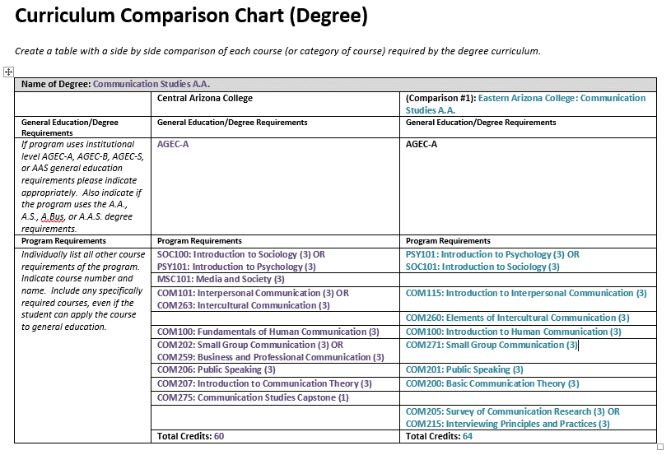

If a degree or certificate is addressed in the self-study it must have a curriculum comparison chart submitted. Although this example only has 1 comparison for demonstration purposes, 2 - 3 comparisons will be made. You will place the curriculum for CAC in the left column as demonstrated. Include course number, name and credits. Group courses together if a student has choice. When filling in the comparison columns, use the most similar programs found in the state of Arizona. If 3 comparable programs do not exist in-state, you should include at least one out-of-state program(s). When placing courses from comparable programs, put equivalent or very similar courses in the same rows. Give a unique course a row of its own, as demonstrated. If comparing to an out-of-state program, in the general education requirements, you should just state “Institutionally Required General Education”. Your program review is not meant to review the institutionally required degree requirements of other colleges, just the program specific requirements. However, do include in the listing of program requirements any courses which the program mandates as a general education choice if the student would have other course choices were it not for this program mandate. In the examples above, PSY/ SOC and COM 100 are an example of this type of situation.

**Developing the Action Plan**

After the program receives feedback from peer reviewers on the Review Panel Report, it is time for the program to create the Action Plan. The Action Plan is a key part to making this a process of continual quality improvement. The goals or actions a program chooses to include in its Action Plan should be supported by the appropriate dean. Each goal or action should serve to strengthen or improve the program in some manner during the ensuing five years. Any or all of these goals may be incorporated into and addressed in the operational planning cycle as well, if desired by the program.

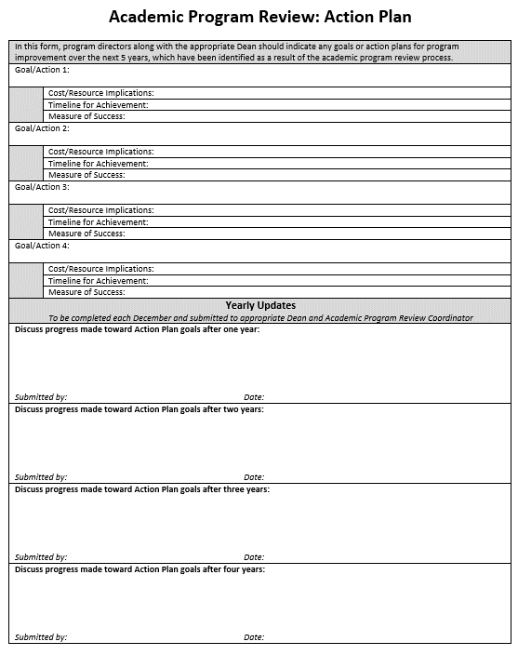

Each December, the program must revisit the Action Plan and write a brief update summarizing the progress made toward the goals. The form is then resubmitted to the appropriate dean and the APR Coordinator to be filed.

There is room for four goals here, but you may have less, or you may add more if you wish.