

**Academic Program Review Handbook**

**2018**

**Table of Contents**

Defining Academic Program Review 3

Overview of the Academic Program Review Process 4

Roles in the Academic Program Review Process 5

Writing the Self-Study 8

Completing Curriculum Comparison Charts 11

Peer Review Process/Peer Review Panel Reports 13

Developing the Action Plan 15

**Defining Academic Program Review (APR)**

In 2012, Central Arizona College, revised its academic program review process, moving from a division-based review to a process focused on assessing and evaluating individual degree and certificate programs. Each degree and certificate program must engage in a self-study every five years. A team of internal peer reviewers evaluate the program using the information provided in the self-study. ALL degree programs and certificates must go through the internal academic program review process even if the program also engages in self-study evaluations for an external accreditation. The academic program review process is governed by Central Arizona College Policy and Procedure 575.

On December 9, 2014, the CAC Academic Program Review Committee approved the following purpose statement which guides the APR process at CAC:

**The Academic Program Review Process will…**

* Evaluate the effectiveness of the academic program in achieving its stated educational goals.
* Evaluate the viability and sustainability of the academic program.
* Evaluate the quality and strengths of the overall program curriculum.
* Ensure the program is aligned with community needs, the college’s mission, and the college’s strategic goals.
* Evaluate the adequacy of resources available to the program, and provide a vehicle for documentation of resource deficiencies.
* Help identify strategic plans and priorities for future enhancement of the academic program.
* Intersect with the curriculum updating processes, student learning outcome assessment processes, and the operational planning process by both providing information for and using information produced from those processes.

In addition, Academic Program Review is an important process according to our regional accreditor, The Higher Learning Commission. It helps us achieve the following accreditation criterion and core components:

**Criterion Four. Teaching and Learning: Evaluation and Improvement**

The institution demonstrates responsibility for the quality of its educational programs, learning environments, and support services, and it evaluates their effectiveness for student learning through processes designed to promote continuous improvement.

**Core Components** 4.A. The institution demonstrates responsibility for the quality of its educational programs. 1. The institution maintains a practice of regular program reviews.

**Overview of the Academic Program Review Process**

Academic program review operates on a five-year cycle, meaning each degree and certificate must complete a self-study once every five years. The process of writing and assessing the self-study occurs during one calendar year, beginning in January and ending in December. The following chart details a basic overview of the process:

Academic Program Review at CAC is a central process in that it provides an opportunity for multiple other processes to intersect and influence one another. Academic Program Review intersects with the following process:

* **External Accreditation –** Programs which have external accreditation reviews should use the internal and external self-studies to inform the other. Generally the internal self-study is briefer, and should be able to pull substantially from the external review, as well as help the program continue to prepare for any upcoming external reviews.
* **Operational Planning –** Programs will develop Action Plans upon receipt of the Review Panel Report. The goals and actions for program improvement can and often should be addressed as operational planning goals.
* **Student Learning Outcome Assessment-** The degree to which students are achieving the learning outcomes in the program and its courses is a key measure of program effectiveness. Thus the Academic Program Review process serves as a key vehicle for reporting and evaluating your assessment results.
* **Curriculum Planning and Revision –** Curriculum is closely related to the effectiveness and viability of the program. As part of the Academic Program Review Process a thorough curriculum evaluation is completed, and thus the APR process should inform a program’s curriculum updating and revision process.

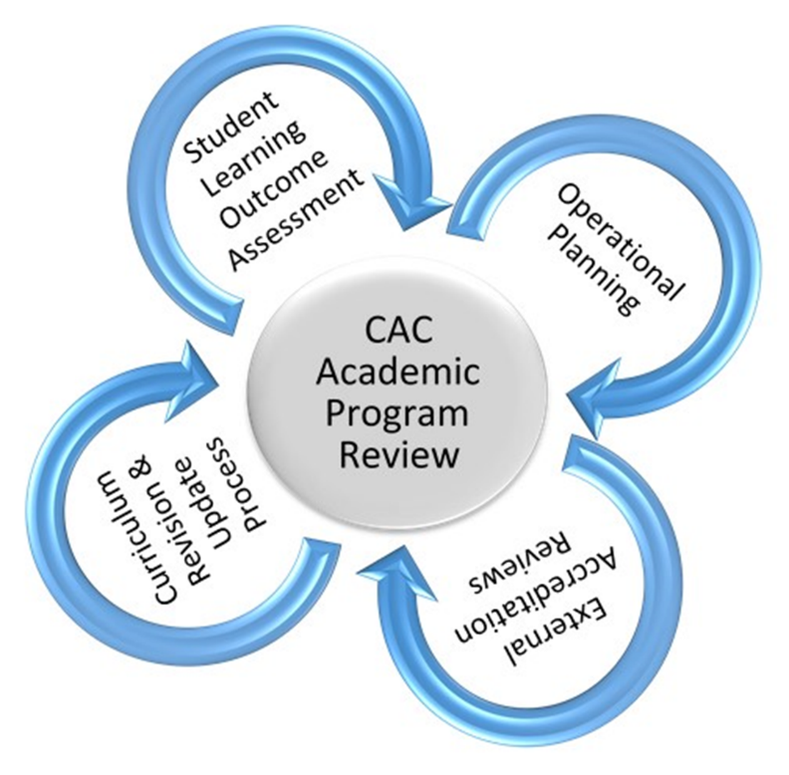

It can be helpful to think of the APR process serving as the central point in this intersection, it is influenced by as well an influencer of the other processes surrounding it.

**Roles in the Academic Program Review Process**

Many people are involved in the Academic Program Review Process. One of the most important roles is that of CAC’s **Academic Program Review Committee**. This committee is the “owner” of the process.

**The Committee Charge:**

Create a systematic process for instructional program review that ensures quality teaching and learning, relevancy of curriculum and instruction, and fulfillment of the program’s mission. The committee will continually evaluate and make recommendations for improvement to the program review process.

**The APR Committee’s Responsibilities:**

* Monitor, recommend and approve any changes to the Academic Program Review Process
* Monitor, recommend and approve any changes to academic program review templates and tools used in the process.
* Approve Program Cycle
* In conjunction with coordinator write and submit to CAO overall summary report of Academic Program Review each year.
* Be an advocate for the value of academic program review at CAC

Another key role in the process is that of the **Academic Program Review Coordinator.** The coordinator works with others involved to ensure that the self-studies are completed and evaluated in a high quality and timely manner. The Academic Program Review Coordinator is selected by and reports to the Chief Academic Officer.

**Job Description of the Coordinator:**

The coordinator is a faculty member with 3 credit hours of release time during fall and spring semesters and is paid a stipend for the academic year equal to 3.5 hours at adjunct pay who has expertise in the area of academic program review. The coordinator facilitates the process and works with self-study writers and peer reviewers to ensure that the self-studies and reviews are of high quality and completed on time. The coordinator works with programs to ensure that they use recommendations and information from the review process to make improvements to the academic programs at Central Arizona College.

**Academic Program Review Coordinator Responsibilities:**

* Assemble and provide training, guidance and assistance to those writing the self-studies.
* Receive completed self-studies from writers and deliver self-studies to the peer review teams for assessment.
* Ensure well-balanced and unbiased peer review teams are in place to review each self-study.
* Provide training, guidance and assistance to peer reviewers during the review process.
* Ensure peer review teams complete their work by due date, receive Review Panel Reports from the teams and forward them to appropriate Dean, CAO, and academic program leader.
* Continually keep the program cycle updated by adding and deleting programs as necessary.
* Attend APR Committee meetings.
* Ensure that Academic Program Review information and materials are updated and available to all who need them.
* Communicate with Deans and CAO as needed on all aspects of Academic Program Review.

People who manage CAC’s academic programs typically have the job title of Division Chair, Director, or Coordinator and they serve in the capacity of the **Self-Study Writers**. While they may certainly enlist assistance from others on their staff, the job of ensuring that the self-study is completed falls to them. These Self-Study Writers may also enlist the assistance of the Dean, the APR Coordinator, and the Office of Institutional Research in order to complete the self-study.

**Self-Study Writers Responsibilities:**

* Attend training for self-study writers offered by APR coordinator.
* Work with the APR coordinator, dean, and others to ensure the self-study is complete, accurate, and well-written.
* Submit the self-study by Sept. 7 to dean and APR coordinator.
* Meet for clarifications with peer reviewers if requested.
* Develop and follow up with Action Plan appropriately

**Peer Reviewers** are involved in the process after the self-studies are complete. Peer reviewers are typically faculty, preceptors, or staff who work directly with academic programs, or act as academic advisors. If you wish to serve as a peer reviewer please speak to your dean, program director, division chair or to the APR Coordinator. The APR Coordinator solicits deans, program directors, and division chairs each spring for the names of people who will serve as peer reviewers that coming fall.

**Responsibilities of Peer Reviewers**

* Attend peer review training offered by APR coordinator.
* Offer an honest and constructive evaluation of the self-study, as it is submitted, according to the criteria established in the Review Panel Report.
* Meet with the self-study writer(s) for clarification of self-study if necessary.
* Return completed Review Panel Reports to the APR coordinator by Oct. 15, indicating which of the following categories they have indicated for the academic program.
  + One of exceptional quality which should be continued
  + One of quality which should be continued
  + A program which should be conditionally continued
  + A program which should be discontinued

**Academic Deans** are also integral to the process. They can assist in the writing/compiling of the self-study if they wish. They assist in identifying peer reviewers. They are key to ensuring that programs follow up with the feedback received from peer reviewers as well as ensuring that the program is developing a strong Action Plan to address any key weaknesses discovered during the Academic Program Review process.

**Writing the Self-Study**

If you are part of a team which will be writing a self-study, you will be invited by the APR Coordinator to attend a training session. The process and forms will be explained, and you will have an opportunity to ask questions. The APR Coordinator will be available to help you continuously throughout the process of writing the self-study.

Self-Studies are completed using the template approved by the APR Committee. Each year the APR Committee will solicit feedback to the process, and may make revisions as needed. It is a goal to keep the process as stable as possible; however, sometimes changes are needed. Below you will find the 2015 template along with basic guidance for completing it. If you are using this manual after 2015, please check with the APR Coordinator or APR Committee to ensure that you have the most up-to-date template, as minor changes may have been made.

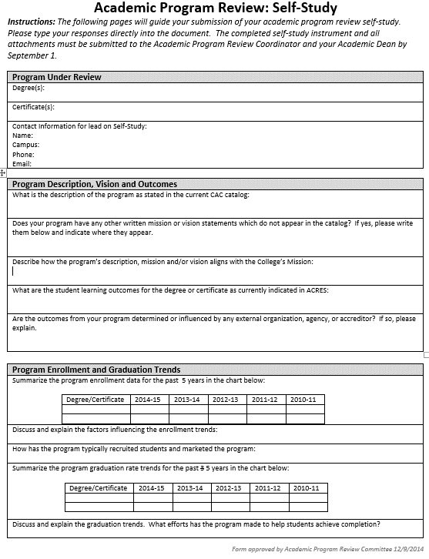

No more than one degree should be addressed in a self-study. Any certificates closely related to the degree and that share significant curriculum may also be included in the same self-study.

Data for these charts can be found in the CAC Fact Book, or contact the Office of Institutional Research. If you provide data other than that supplied by the Office of Institutional Research please explain why the data you have provided is more accurate than the institutionally supplied data.

If needed, assistance on this can be provided by the Office Curriculum and Student Learning Assessment.

Each degree or certificate has a description in the CAC catalog. Include and clearly label the description for each degree or certificate addressed in the self-study

This should reflect the name of the division chair, program director or coordinator.

Please see instructions for the Curriculum Comparison Chart elsewhere in the handbook. In this section, discuss what you learned about the program curriculum by making the comparisons.

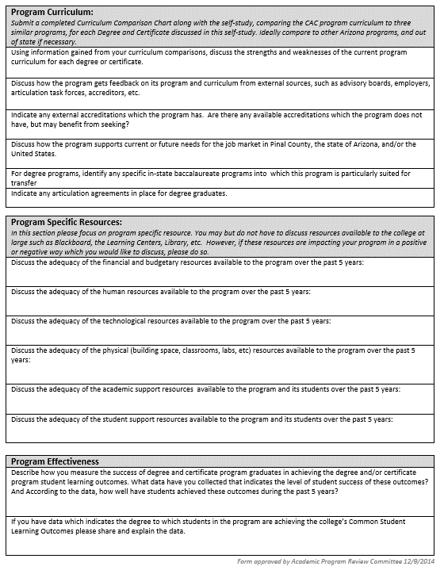

Provide as specific data as possible regarding the demand or likely future demand for students with credentials such as those offered by this academic program. Assistance may be provided by the Office of Institutional Research in obtaining this data.

If unsure, assistance can be provided by the Office of Curriculum and Student Learning Assessment.

In this section focus on the PROGRAM level learning outcomes. Have you assessed them? If so what data do you have? If it is a new program with no graduates yet, what vehicle(s) do you have in place which will allow program level assessment? Program level assessment often takes the form of licensure exams, capstone courses, final portfolios, etc.

In this section please focus on resources which are predominantly used by your program. You may discuss college-wide resources such as BlackBoard if there is something in particular you wish to mention about the resource in regards to your program.

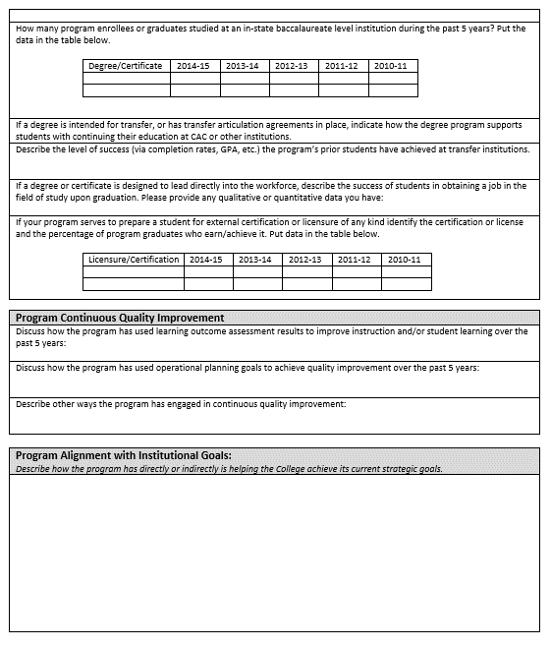

Work with the Office of Institutional Research to determine if this data is available for your program.

Describe how your program supports successful transfer for program completers.

Work with the Office of Institutional Research to determine if this data is available for your program.

This data can be hard to obtain, but please discuss what you have or describe how the program is working toward obtaining this data.

In this section offer a narrative of the program’s quality improvement efforts over the past 5 years.

In this final section, describe how the program is helping the college achieve its current strategic goals. You do not need to address each goal, just the ones which the program helps achieve.

**Completing Curriculum Comparison Charts**

A key part of the self-study is a close examination of the program’s curriculum. The curriculum comparison charts are meant to aid this process, and a chart should be completed for EACH degree and certificate addressed in a self-study.

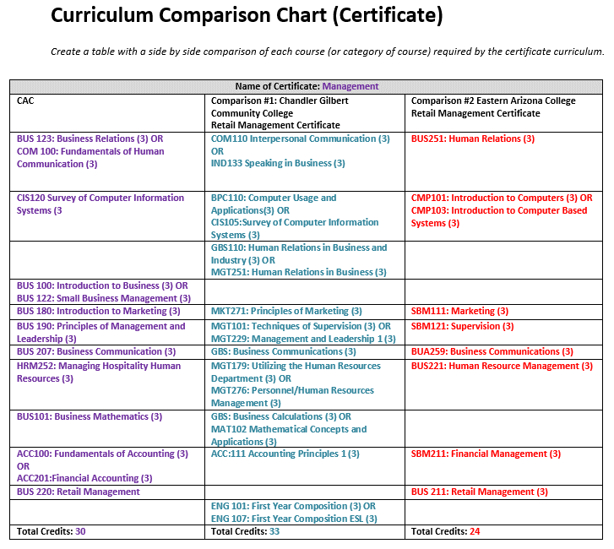

Each certificate addressed in the self-study must have a curriculum comparison chart submitted. Although this example only has 2 comparisons for demonstration purposes, 3 comparisons will be made. You will place the curriculum for CAC in the left column as demonstrated. Include course number, name and credits. Group courses together if a student has choice. When filling in the comparison columns, use the most similar programs found in the state of Arizona. If 3 comparable programs do not exist in-state, you should include out-of-state program(s). When placing courses from comparable programs, put equivalent or very similar courses in the same rows. Give a unique course a row of its own, as demonstrated.

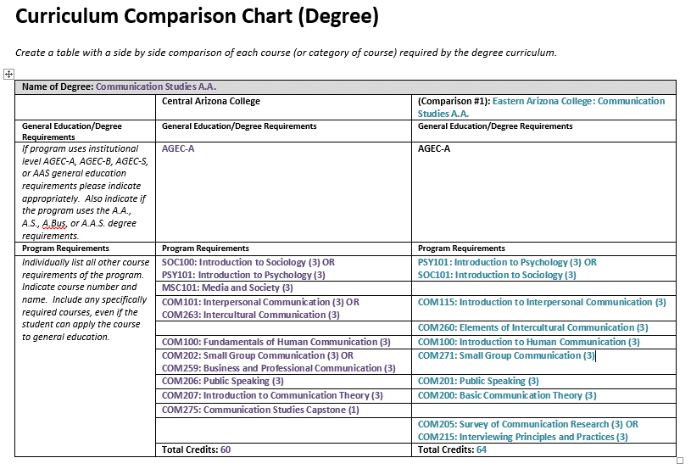

If a degree is addressed in the self-study it must have a curriculum comparison chart submitted. Although this example only has 1 comparison for demonstration purposes, 3 comparisons will be made. You will place the curriculum for CAC in the left column as demonstrated. Include course number, name and credits. Group courses together if a student has choice. When filling in the comparison columns, use the most similar programs found in the state of Arizona. If 3 comparable programs do not exist in-state, you should include out-of-state program(s). When placing courses from comparable programs, put equivalent or very similar courses in the same rows. Give a unique course a row of its own, as demonstrated. If comparing to an out-of-state program, in the general education requirements, you should just state “Institutionally Required General Education”. Your program review is not meant to review the institutionally required degree requirements of other colleges, just the program specific requirements. However, do include in the listing of program requirements any courses which the program mandates as a general education choice if the student would have other course choices were it not for this program mandate. In the examples above, PSY/ SOC and COM 100 are an example of this type of situation.

**Peer Review Process**

Self-studies are submitted by September 1 of each calendar year. During the fall each will undergo the process of peer review. Each self-study is reviewed by 3-4 internal peer reviewers who are typically faculty, preceptors, or staff who work directly with academic programs, or act as academic advisors. None of the reviewers should work in any manner directly with the programs under review. Peer reviewers are trained by the APR Coordinator each fall, to help ensure they understand their role and duties. Upon completion of the review, the peer reviewers complete and submit the APR Review Panel Report.

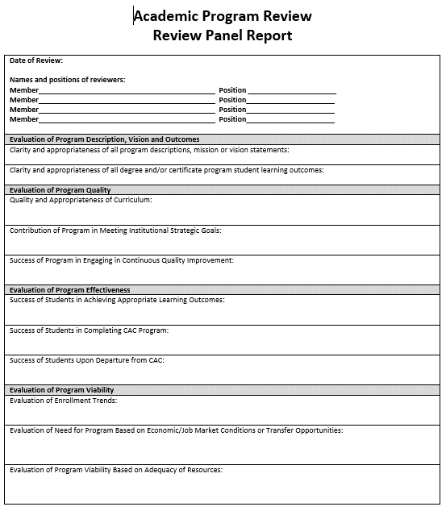

Each peer reviewers name and position is at the top of the report.

In each section, peer reviewers offer a narrative summarizing their overall assessment of the programs under review.

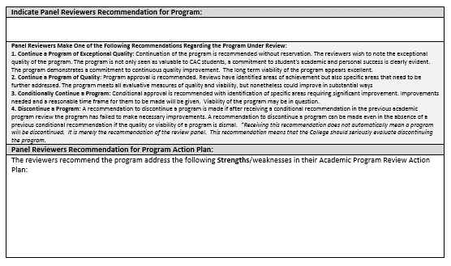

Here, peer reviewers indicate which of the four categories they have determined to place the program(s) in. Peer reviewers recommendations are not binding, as ultimately the decision to discontinue a program is a significant one, and requires the approval of many administrative levels.

In this final section, peer reviewers indicate recommendations they have for the program to consider putting into their action plan. These recommendations are not binding, they are just suggestions from the peer reviewers. Action Plans are ultimately created by the program director, coordinator or division chair and approved by the appropriate dean.

**Developing the Action Plan**

After the program receives feedback from peer reviewers on the Review Panel Report, it is time for the program to create the Action Plan. The Action Plan is a key part to making this a process of continual quality improvement. The goals or actions a program chooses to include in its Action Plan should be supported by the appropriate dean. Each goal or action should serve to strengthen or improve the program in some manner during the ensuing five years. Any or all of these goals may be incorporated into and addressed in the operational planning cycle as well, if desired by the program.

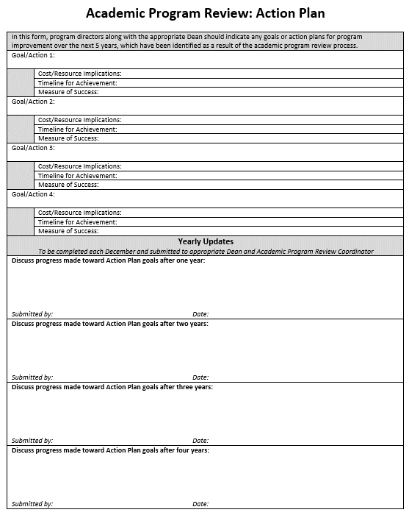

Each December, the program must revisit the Action Plan and write a brief update summarizing the progress made toward the goals. The form is then resubmitted to the appropriate dean and the APR Coordinator to be filed.

There are room for four goals here, but you may have less, or you may add more if you wish.